Celebrating Civil Society
CSO Fair
7-9th Nov 2016

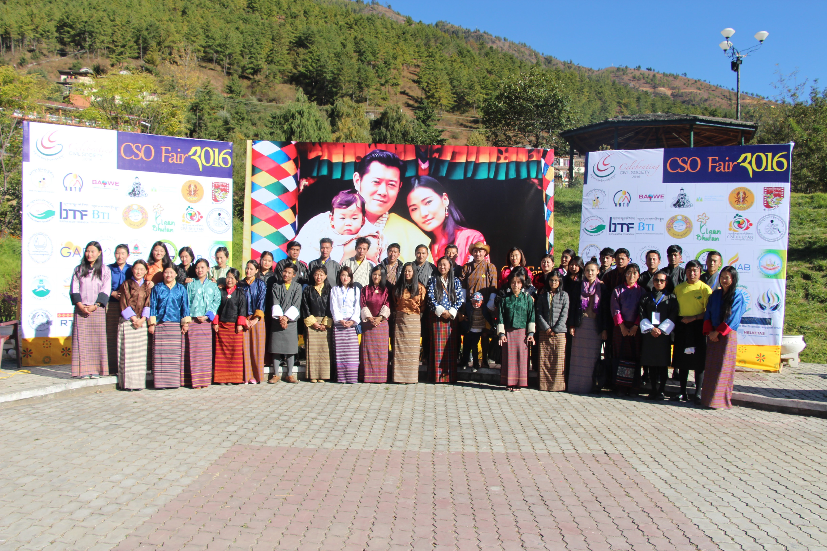

Table of Content

Background--------------------------------------------------------------------------- 3
Aims and Objectives-----------------------------------------------------------------4
Outcome--------------------------------------------------------------------------------4
Lessons Learned----------------------------------------------------------------------4
Annexe 1
Evaluation-----------------------------------------------------------------------------4 - 14
Annexe 2
Pictures-------------------------------------------------------------------------------- 15 - 16

Background:
With an growing civil society space in Bhutan, a 2nd CSO fair was held to provide platform for all the CSOs to present their work in building community and to generate interest in supporting civil society network.
Her Majesty The Gyaltsuen, as the Royal Patron of a number of civil society organization in Bhutan, graced the opening of the Civil Society Fair at Centenary Park on 7th November.
The CSO fair 2016 was a thematic exhibition of CSO work. In celebrating CSOs and CSOs presence, the fair focused on the 4 pillars and 9 domains of GNH, creating an exhibition that revolves around the 5 main interrelated themes.
Each CSOs were grouped under different thematic groups based on their nature of the work. The Fair focused on exhibiting and sharing the success stories and their work in line with the theme for the fair.
From exhibition of local products to free vet care, CSOs came together to educate and create awareness not only to the public but also to the policy makers on the work on CSOs.
Total of 37 CSOs, both Public benefit organization (PBO) and Mutual Benefit Organisation (MBO) participated in the fair. The core committee member of CSOs helped to steer the whole fair, hosting discussion and planning with rest of the CSOs.
The CSO fair was funded and supported by Helvetas Swiss Intercooperation

Aims and Obejectives:

- To showcase the work of civil society in contributing to the common interests and good

- To highlight some of the needs of civil society organization – and to generate interest in supporting civil society

- To promote networking and collaboration amongst CSOs

Outcome:

- A participatory thematic fair/exhibition based on the concept of celebrating the presence and work of civil society

Lesson Learned:

- Need more in-depth planning not only among core committee members but also among those participating CSOs
- Need more advertisement not only through broadcast and print but also outdoor advertisement
- Need to have more engaging activities and presentations by the participating CSOs instead of just selling their products
- The location should be in the centre of the town so that the fair will easily be noticeable by the public
- Maybe need to have separate office and a person responsible for planning and steering the fair
- Need to have clearer understanding of roles and responsibilities heads of the thematic group

Annexe 1
Evaluation:
Evaluation survey for CSO members
- What did you like best about the CSO fair 2016?

- Was the Fair beneficial to your organization?

- In which way did the fair benefit your organization?

- What is the most important thing you learnt from participating in the CSO Fair, that your organization can apply in its civil society work?

- Do you have any suggestions for improving the CSO fair or other CSO collaborations for the future?

- Need more in depth planning (
- Need to advertise more especially out door advertisement
- Need to be conducted on weekends
- Make it more engaging instead of only showcasing/seliing products (2
- which makes it look more like a trade fair
- Allocate budget to each CSOs with a ceiling and let them prepare their programme within that budget
- Time management for presentation
- More commitement, team wore and sense of ownership
- Need to change the location to place where public can easily see us
- Coordination among members to be strengthened
- Displays can be more organized
- Can have more cultural programmes and at least one food stall
- No proper instructions to all the CSOs
- Too many leaders directing the same responsibility caused lot of chaos at the eleventh hour
- Need to brain storm together and come up with better ideas for the next fair. It needs to be exciting so that we can draw in more crowd
- Insufficient space/no proper allocation of space
- Informing stake holders beforehand so that they make time for us

Evaluation for the general public
- What did you like best about the CSO fair?

- What did you learn about Civil Society in Bhutan?

- Would you like to support Civil Society? How?

- Through donation
- Through volunteerism
- By buying local products
- By spreading good words on CSOs
- Through volunteerism but CSOs need to provide more information
- By advocating CSOs needs and attending CSO programmes
- By volunteering in those organization I am interested in

- What would you suggest we do to improve the CSO fair in the future?
- Need more advertisement
- Location should be in the central of the town
- Educating people on your work instead of selling products
- Make a 2 min presentation by all the CSOs
- Need more cultural/live performance by local artisans
- Need to work explain about their mission
- No improvement needed
- Provide more information
- No comment, it was a good opportunity to learn and explore CSOs

Evaluation feedback from CC members

Evaluation feedback from CC members
- Did the process of organizing the CSO Fair strengthen your relationship with other CSOs? How?
Yes among CC members:
- More intense communication and collaboration, more personal engagement with the Core Committee members.
- This was inspiring as a personal motivation to make the CSO Fair a success was very high!
- The fair was a good platform to get to know other CSOs and understand about each other’s work and identify mutual interest for future collaboration.
- Through the collaborative work and planning. And the friendships that were made through the various programme activities, including the brief practise runs for the entertainment programme.
- In the process of getting the work done.

No:
- Relationships with other CSOs have not really been strengthened, as they did not engage during the CSO Fair preparation despite requests.
- Realized how difficult it is to coordinate with many CSOs and most cases it is because of the limited human resources and of course their priority.
- Could have been better: Due to lack of active participation, engagement and coordination there was hardly any meaningful interaction. Most heads were not participating.
- Limited human resources and of course their priority (we did not see the CSO Fair as a priority for them).
- Fair at-least created a platform to try and bring as many CSOs as possible.

Sl no | Yes among Core committee members | No, not among other CSOs | No answer
1. | 5 | 5 | 0

2. Do you feel the Core Committee had enough support from all the CSOs for organizing the CSO Fair, and was truly representative of all CSOs? Why?
Yes, was truly representative of all CSOs
- The CC is representative and did represent all CSOs while organizing the CSO Fair.

Not Really
- CSOs did not readily engage or communicate on requests from CC and left the work thus nearly fully to the CC. Some CSO stands also showed limited preparation for the Fair, while a budget was available, which is a lost opportunity for them.

- The support received from the other CSOs was very poor. The CC tried their best to make it a CSO fair with representation and participation from all the CSOs, however, there was a total lack of enthusiasm and support from the other CSOs and the CC members had to worry and work for long hours to assure the success of the fair. Despite repeated phone calls and email communication, it is very hard to build the support network that CC hoped for.

- No, Lack of time, planning and allocation of resources (Fund/ People) e.g. Chadi group would have required more people and advance.

- The support was inadequate as much of the work fell on the core committee. We could do more to get this support. We ought to have spelt it out more plainly and taken more time to build the task groups with clear TOR and duties. This is a process of networking that has to be strengthened.

- Not really, not all the CSOs were forthcoming and had to be reminded many times before they showed up for the meetings.

Sl no | Yes ,was truly representative of all CSOs | No, was not truly representative of all CSOs | No Answer
1. | 1 | 5 | 0

3. What did you learn from organizing the CSO Fair that the Core Committee can take further to strengthen CSO networking and joint action?
Learned
- The fair was a good event to understand the complexity of organising an event with representation from large number of organisations.
- Advance planning and budgeting
- We need to create larger task groups with TORs clearly listed.
- More CSOs should be involved actively; some of us (CC esp chadri group) members did not engage them right from the beginning and struggled to get them on board last hour.
Suggestions
- More active engagement of all CSOs and pre-agreement with all CSOs who like to participate in the fair that they also support and engage to promote through their network and pro-actively communicate about the CSO Fair. This will help in reaching more people to attend, then can be reached through formal media coverage and banners.
- Engage all CSOs at-least couple of times for discussion and finalization
- Come out with standard guideline on CSO fair (say after the 2nd or 3rd fair) that can be shared with CSOA for future fairs.

- For future events, the organising committee or group is recommended to sign a MoU with every CSO with detailed outline of their roles and responsibilities. Further, it is better to have individual CSO to come with their own exhibits and creative idea rather than to club them under themes as we did this time (under the GNH themes).

- Entertainment program could include more participation from civil soc groups and provide time for CSOs to advocate for their causes in front of a crowd.

Chadi – could be improved with more members and to try and outsource as much as possible. Attention to details like decorations, arrangements need more attention in future especially in case of VIP chief guests.

Publicity – using a social media campaign pre and post, as well as the media and word of mouth.

Invitations – every CSO could be prompted to invite not just their board members but to reach out to their friends and families for participation.

More participatory type activities are needed – more hands on experiences.
- Responsibilities to given to different CSOs and not to be taken up fully by the CC members for the ownership of the event, CC members can facilitate.

- Engage CSOs in networking and communication on the CSO Fair to better spread the news. Also to make a pre-agreement on some minimum contributions from participating CSOs in the quarterly meeting before the CSO Fair. Also an earlier start with planning and preparation.

- The fair should be planned in the beginning of the year with clear division of responsibilities. CSO’s commitment and participation in the fair should be undertaken by the head of the CSOs and not by other officials. Rather than have the fair in Thimphu, it would be also good to take it to different districts.

- (Fix dates in advance (minimum 6 months). Finalise theme
- Create activities that brings CSOs together
- Use of fair more than showcasing activities and products like launching, announcement, making collaboration/ MoU to implement similar or complementing activities, membership drive, recruitment and employment, volunteer drive etc…
- Debriefing meeting after the fair
- Set up a Fair office where task group members can sit together and work together at least in the last couple of weeks before the event.
- Create a system to enable individual CSOs to print and produce their own advocacy materials and posters. The core group to focus only on the common materials for the fair as a whole.
- Step up on our co-ordination.
- Try and involve CSOA as a participant.
- Create a master plan of the flow of the tents etc and make it available to all CSOs so they know where to set up.
- Create plans for every process – entertainment, protocol, chadi, table allocations, budgets etc
- Layout of the event is crucial to make sure that everybody is placed in the most appropriate manner at the venue.
- Venue and time is the most important factor to get our message clear, this year because of the timing, we were not able to gather as much crowd as we anticipated. Nevertheless, we were fortunate to get Her Majesty The Gyaltsuen as the guest of honour.
- Having Food Stalls would also attract people
- Outsourcing the whole Chadri will need to be thought of once again, as there were many things that the Events Management did not have the competency to do and lot of fire fighting roles had to be played at the last hour. However, due to the election holiday and the time taken for approval of the main venue led to delay in chadri works, the events management team could not complete their work on time. Also, DNP not having a single manpower to help with the traditional tents etc led to outsourcing of the work to another events management team. This is because of the clash of events at Lingkana as well as the Melonam Chenmo.

5. Any general comments on CSO development and collaboration?
- Better understanding expectations of CSOs; where action and strengths is in working through the CC, where in engaging as a whole network and where CSOs better work individually. Limited capacities need to be utilized efficiently, while not raising unrealistic expectations.

- The CSO network and collaboration has to be strengthened so as to work on CSO development activities. In order to strengthen network, events like CSO networking dinner or retreat has to be organised. The CSOA also has to play the facilitator role to facilitate such network rather than just leaving it to CC or the two eminent members.
- More networking events-Supplementing and collaborating similar activities among CSOs
- Support from Govt. to CSOA (Staff and Resources)
- Overall, the event was a success in terms of advocacy and we got the attention of the decision-makers we needed. It’s put Civil Society in public domain. We could step up the collaboration with more careful planning.
- A long way to go! I am not sure how we can overcome this challenge, without this, it will be difficult to work together.

Annexe 1
Pictures:

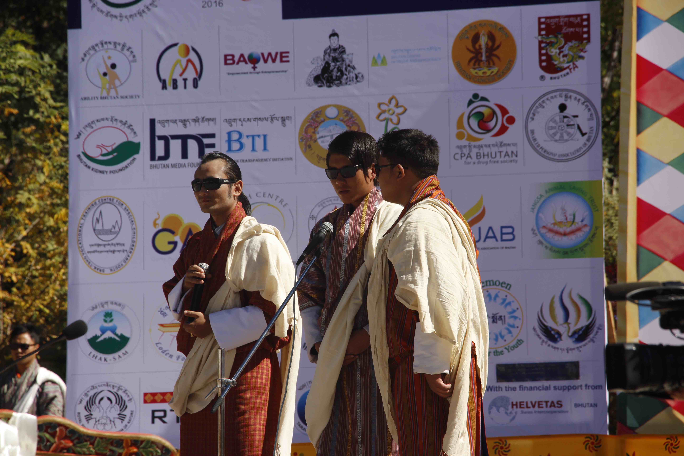 Members from Disabled Person Association of Bhutan (DPAB) presenting a song

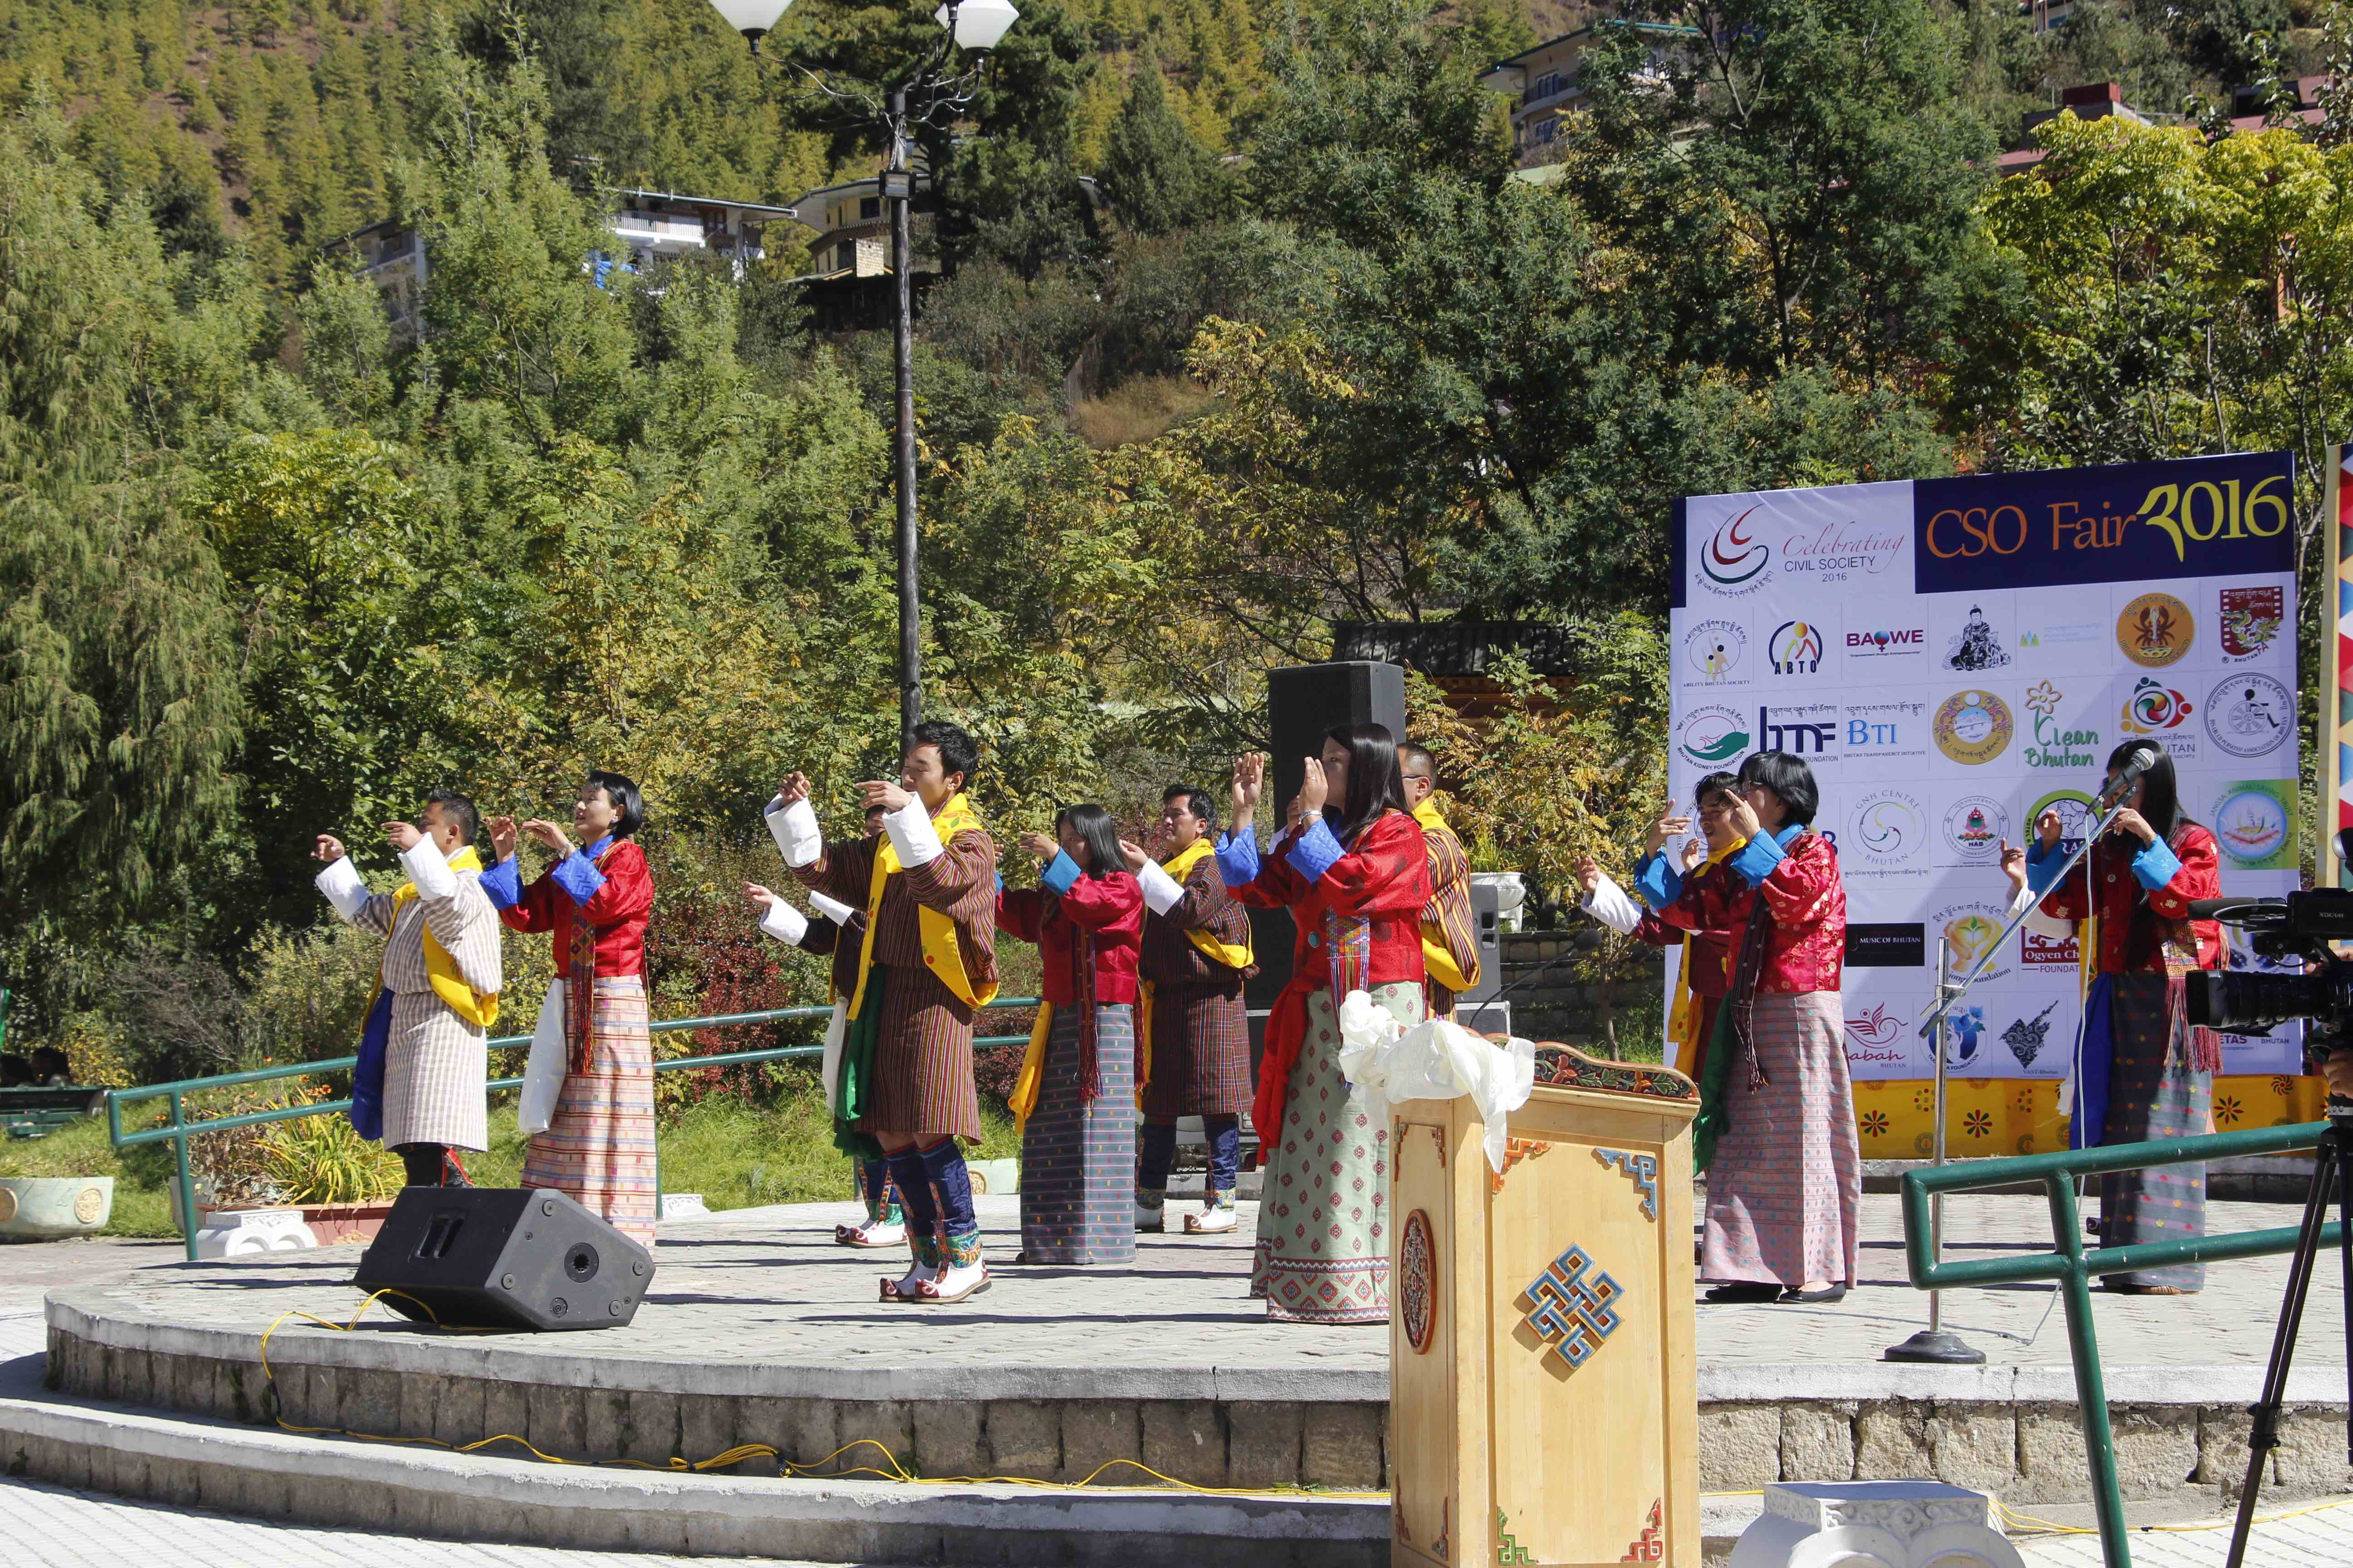 A welcome dance by head of various CSOs

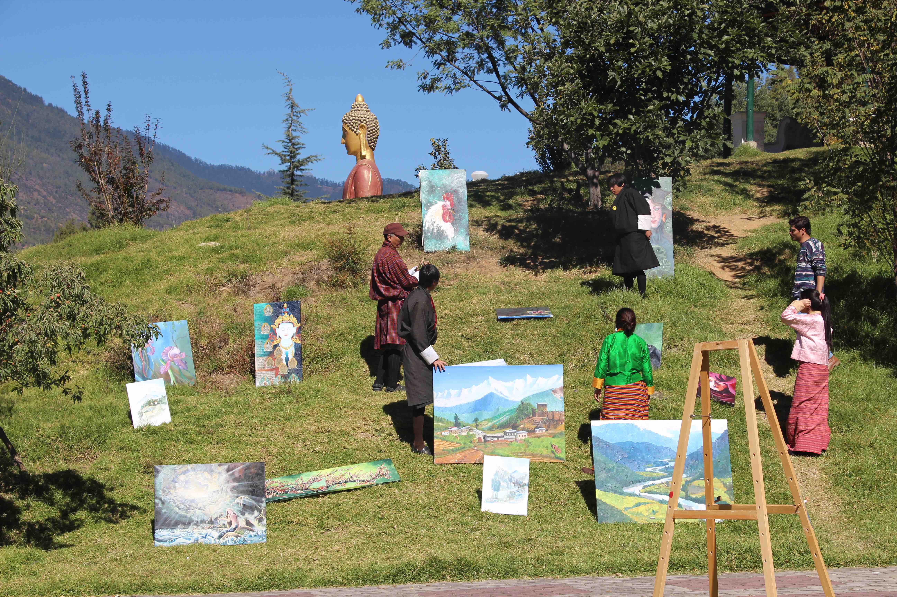 MBO Vast displaying their artwork
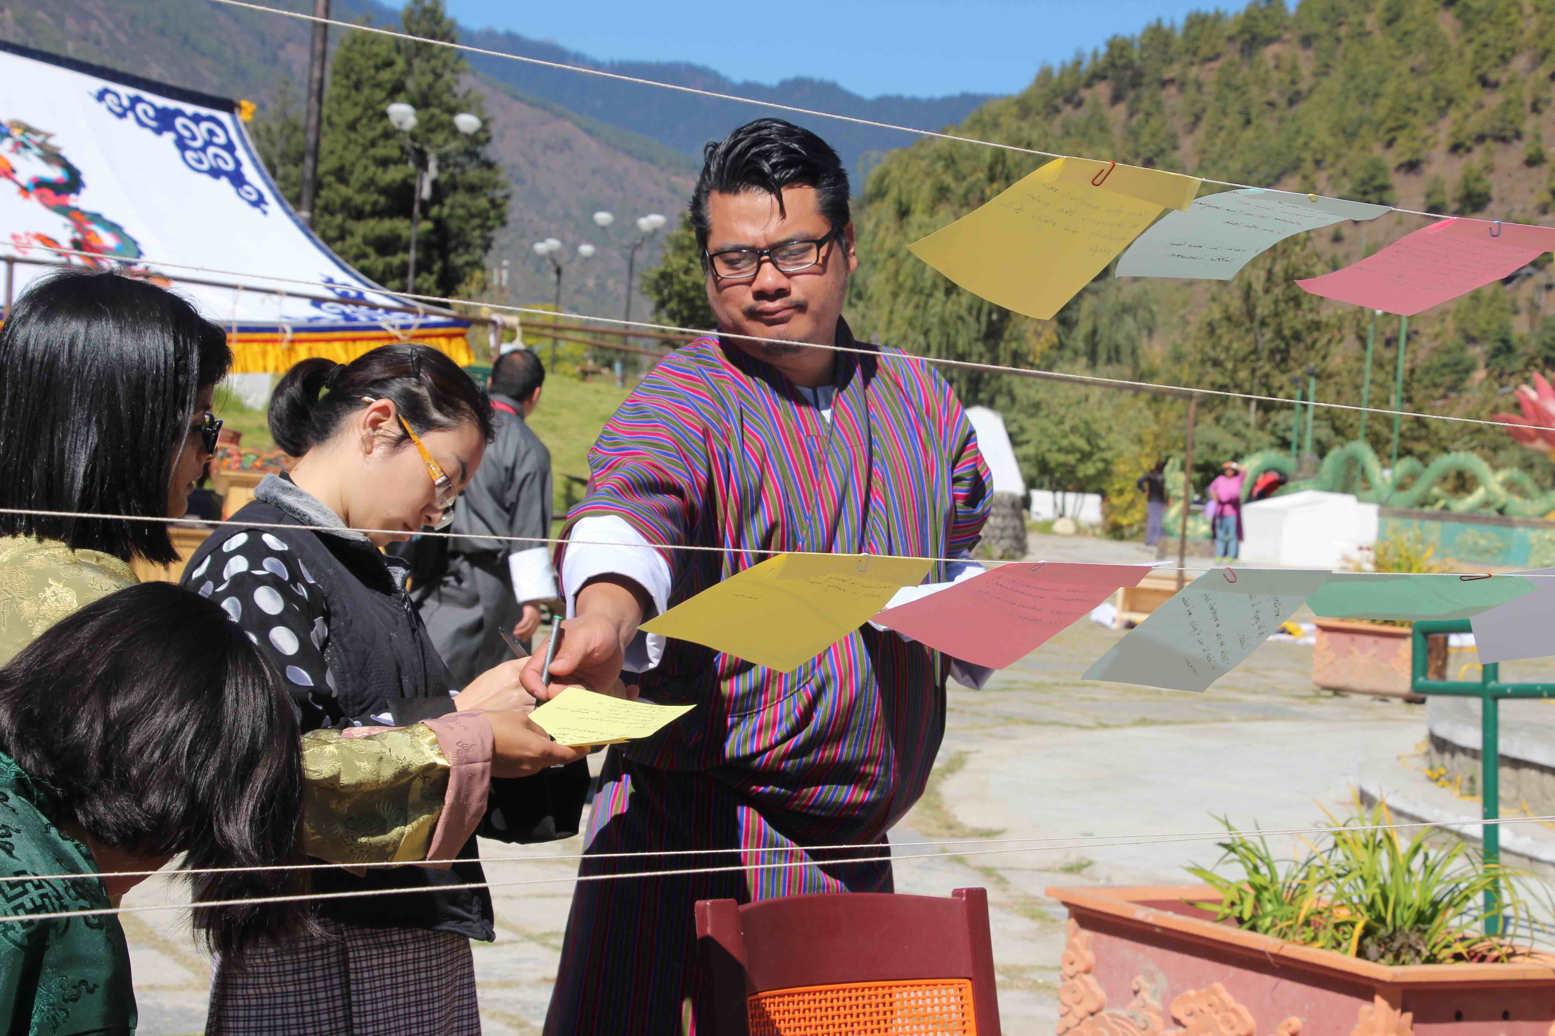
A journalist and a member of CSO identifies issues that need attention today and explains about how civil society can serve the society better

